**Bài tập tuần 3**

1. Có Button sign in FaceBook & sign up
   1. Source Code

Activity_main.xlm

*<?xml version="1.0" encoding="utf-8"?>  
<RelativeLayout xmlns:android="http://schemas.android.com/apk/res/android"  
 android:layout_width="match_parent"  
 android:layout_height="match_parent"  
 android:padding="16dp"  
 android:background="#fff">*

*<!-- Tiêu đề SIGN IN -->  
 <TextView  
 android:id="@+id/tvTitle"  
 android:layout_width="wrap_content"  
 android:layout_height="wrap_content"  
 android:text="SIGN IN"  
 android:textSize="20sp"  
 android:textStyle="bold"  
 android:layout_centerHorizontal="true"  
 android:layout_marginTop="30dp"/>  
  
 <!-- Label Username -->  
 <TextView  
 android:id="@+id/tvUsername"  
 android:layout_width="wrap_content"  
 android:layout_height="wrap_content"  
 android:text="Username:"  
 android:layout_below="@id/tvTitle"  
 android:layout_marginTop="40dp"  
 android:layout_alignParentStart="true" />  
  
 <!-- EditText Username -->  
 <EditText  
 android:id="@+id/edtUsername"  
 android:layout_width="match_parent"  
 android:layout_height="wrap_content"  
 android:hint="name@gmail.com"  
 android:inputType="textEmailAddress"  
 android:layout_toEndOf="@id/tvUsername"  
 android:layout_alignBaseline="@id/tvUsername"  
 android:layout_marginStart="20dp"  
 android:layout_marginBottom="15dp"/>  
  
 <!-- Label Password -->  
 <TextView  
 android:id="@+id/tvPassword"  
 android:layout_width="wrap_content"  
 android:layout_height="wrap_content"  
 android:text="Password:"  
 android:layout_below="@id/edtUsername"  
 android:layout_alignParentStart="true"  
 android:layout_marginTop="20dp"/>  
  
 <!-- EditText Password -->  
 <EditText  
 android:id="@+id/edtPassword"  
 android:layout_width="match_parent"  
 android:layout_height="wrap_content"  
 android:hint="******"  
 android:inputType="textPassword"  
 android:layout_toEndOf="@id/tvPassword"  
 android:layout_alignBaseline="@id/tvPassword"  
 android:layout_marginStart="20dp"/>  
  
 <!-- Button Sign In -->  
 <Button  
 android:id="@+id/btnSignIn"  
 android:layout_width="wrap_content"  
 android:layout_height="wrap_content"  
 android:text="SIGN IN"  
 android:layout_below="@id/edtPassword"  
 android:layout_alignParentEnd="true"  
 android:layout_marginTop="20dp"  
 android:paddingLeft="20dp"  
 android:paddingRight="20dp"/>  
  
 <!-- Button Sign In via Facebook -->  
 <Button  
 android:id="@+id/btnFacebook"  
 android:layout_width="match_parent"  
 android:layout_height="wrap_content"  
 android:text="SIGN IN VIA FACEBOOK"  
 android:background="#ccc"  
 android:textColor="#000"  
 android:layout_marginBottom="30dp"  
 android:layout_above="@+id/btnSignUp"/>  
  
 <!-- Button Sign Up -->  
 <Button  
 android:id="@+id/btnSignUp"  
 android:layout_width="match_parent"  
 android:layout_height="wrap_content"  
 android:text="SIGN UP"  
 android:background="#ccc"  
 android:textColor="#000"  
 android:layout_alignParentBottom="true"  
 />  
  
</RelativeLayout>*

Main_activity.java

*package com.example.thelab2;  
  
import android.os.Bundle;  
import android.view.Gravity;  
import android.widget.LinearLayout;  
import androidx.appcompat.app.AppCompatActivity;  
  
public class MainActivity extends AppCompatActivity {  
  
 @Override  
 protected void onCreate(Bundle savedInstanceState) {  
 super.onCreate(savedInstanceState);  
 setContentView(R.layout.activity_main);  
  
  
  
 }  
}*

* 1. **Hình Ảnh**

1. Chỉ có sign in
   1. Source code

*Activity_main.xml*

*<?xml version="1.0" encoding="utf-8"?>  
<RelativeLayout xmlns:android="http://schemas.android.com/apk/res/android"  
 android:layout_width="match_parent"  
 android:layout_height="match_parent"  
 android:padding="16dp"  
 android:background="#fff">  
  
 <!-- Tiêu đề SIGN IN -->  
 <TextView  
 android:id="@+id/tvTitle"  
 android:layout_width="wrap_content"  
 android:layout_height="wrap_content"  
 android:text="SIGN IN"  
 android:textSize="20sp"  
 android:textStyle="bold"  
 android:layout_centerHorizontal="true"  
 android:layout_marginTop="30dp"/>  
  
 <!-- Label Username -->  
 <TextView  
 android:id="@+id/tvUsername"  
 android:layout_width="wrap_content"  
 android:layout_height="wrap_content"  
 android:text="Username:"  
 android:layout_below="@id/tvTitle"  
 android:layout_marginTop="40dp"  
 android:layout_alignParentStart="true" />  
  
 <!-- EditText Username -->  
 <EditText  
 android:id="@+id/edtUsername"  
 android:layout_width="match_parent"  
 android:layout_height="wrap_content"  
 android:hint="name@gmail.com"  
 android:inputType="textEmailAddress"  
 android:layout_toEndOf="@id/tvUsername"  
 android:layout_alignBaseline="@id/tvUsername"  
 android:layout_marginStart="20dp"  
 android:layout_marginBottom="15dp"/>  
  
 <!-- Label Password -->  
 <TextView  
 android:id="@+id/tvPassword"  
 android:layout_width="wrap_content"  
 android:layout_height="wrap_content"  
 android:text="Password:"  
 android:layout_below="@id/edtUsername"  
 android:layout_alignParentStart="true"  
 android:layout_marginTop="20dp"/>  
  
 <!-- EditText Password -->  
 <EditText  
 android:id="@+id/edtPassword"  
 android:layout_width="match_parent"  
 android:layout_height="wrap_content"  
 android:hint="******"  
 android:inputType="textPassword"  
 android:layout_toEndOf="@id/tvPassword"  
 android:layout_alignBaseline="@id/tvPassword"  
 android:layout_marginStart="20dp"/>  
  
 <!-- Button Sign In -->  
 <Button  
 android:id="@+id/btnSignIn"  
 android:layout_width="wrap_content"  
 android:layout_height="wrap_content"  
 android:text="SIGN IN"  
 android:layout_below="@id/edtPassword"  
 android:layout_alignParentEnd="true"  
 android:layout_marginTop="20dp"  
 android:paddingLeft="20dp"  
 android:paddingRight="20dp"/>  
   
</RelativeLayout>*

* 1. Hình ảnh

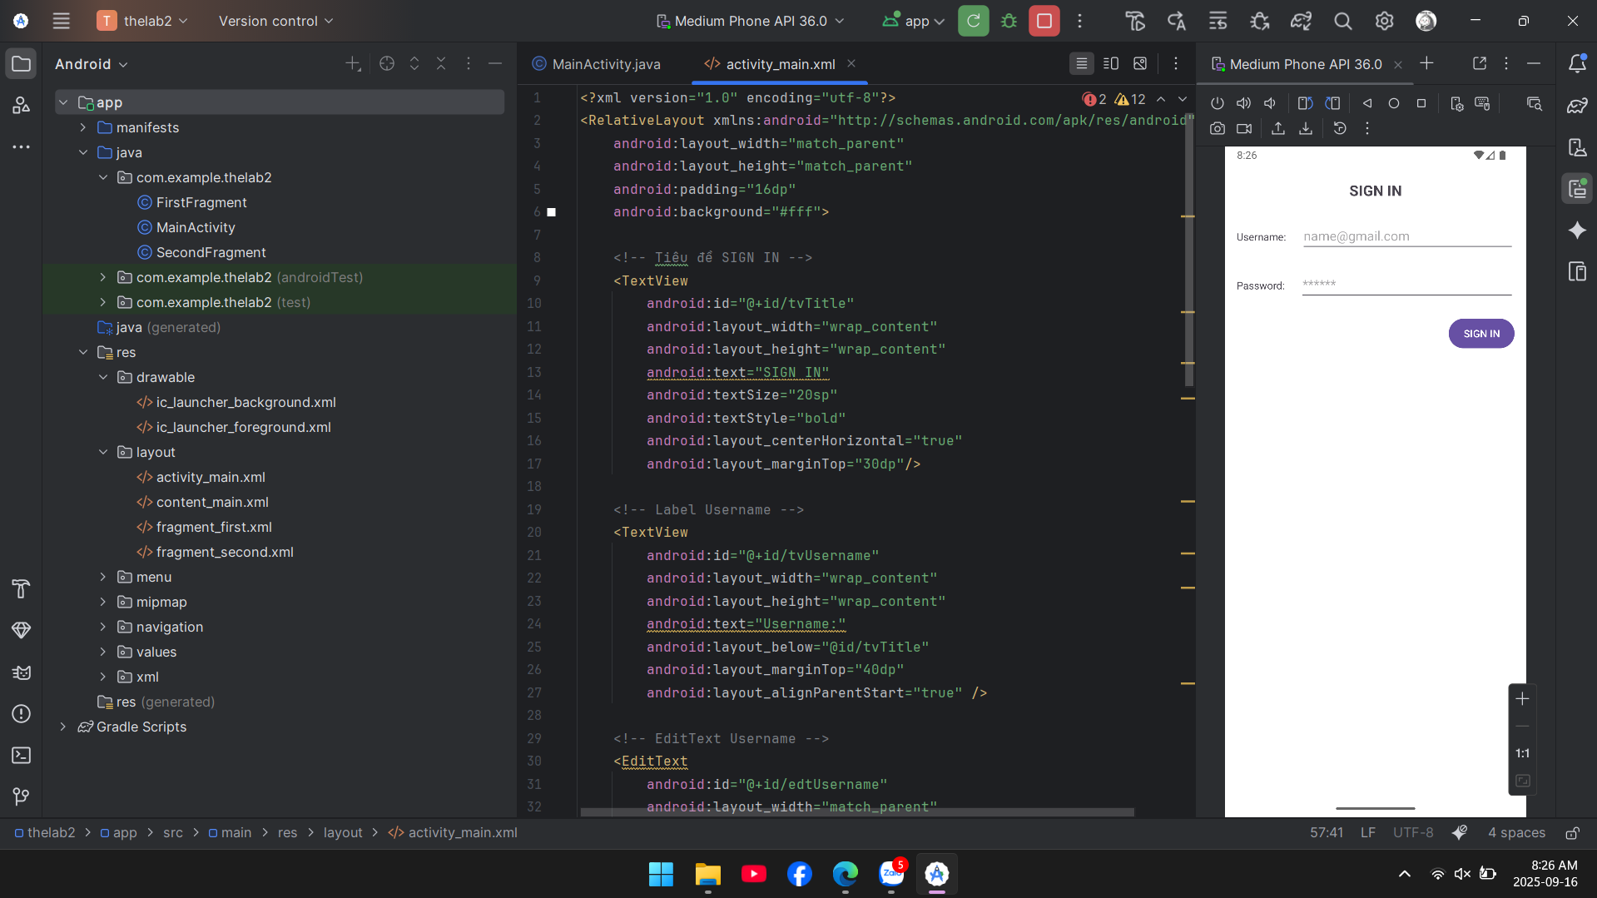

1. **File Project**

